8051 simple calculator c code + proteus simulation
This post provides a simple calculator project code ( using c language ) for 8051 micro-controller ( e-g for AT89C51 or AT89C52 etc ). This is a simple one digit^{[1]} calculator which implements only 4 functions addition(+), subtraction(-), multiplication(x) and division(/).
The code and Proteus simulation is given in the 'Downloads' section at the bottom of this page. It is assumed that you know how to interface LCD and keypad with 8051 micro-controller. If you don't, then please read this post first.
The result of the Proteus simulation is shown below.
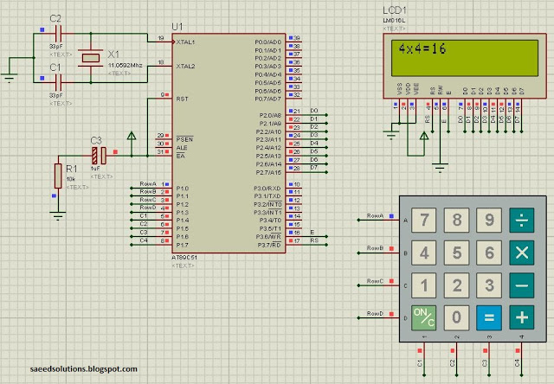
Figure 1. Circuit diagram for implementing calculator on 8051
In the above figure, we can see that a result of "4x4=16" is shown on the screen. To achieve this result, first press '4' from the keypad. Then press 'x' and then press '4' again. After that, on pressing '=' from the keypad the result '16' is automatically displayed on the screen.

Features of this calculator
- You can give any single digit input from 0 to 9.
- You can press 'ON/C' button at any time to reset the calculator.
- 4 functions are implemented i-e addition, subtraction, multiplication and division.
- Error messages are displayed if wrong input is detected. For example, if calculator is expecting a number, but a function key is pressed then 'Wrong Input' message is displayed. Similarly, 'Wrong Function' message is displayed if wrong key is pressed instead of a function key.

Main function code
The code for the main function is shown below.
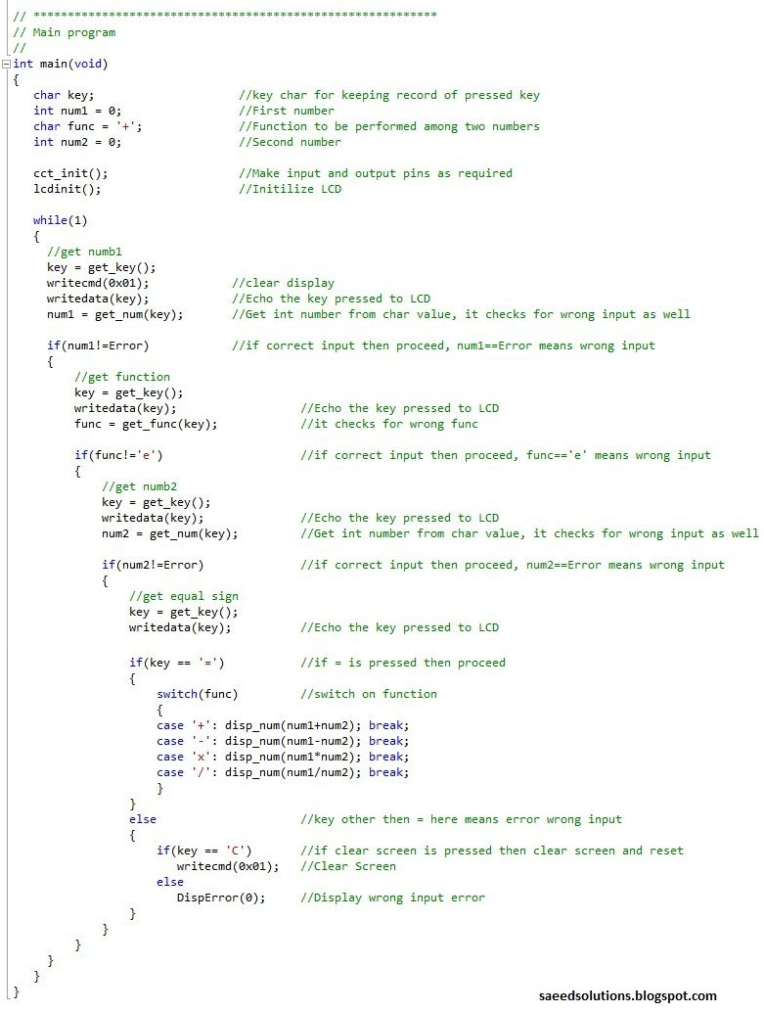
Figure 2. Main code for 8051 calculator implementation
In the main code, firstly LCD is initialized. Then the code waits for the first number^{[1]} from the keypad. After getting this number LCD screen is cleared. And this number is displayed on the LCD. After that, code waits for the function key^{[2]} from the user. After getting the function key, code waits for the second number^{[1]} and then the equal sign. After getting the equal sign, according to the desired function the result is calculated and displayed on the screen.
You can leave your comments in the comment section below.

Notes and References
^{[1]} You can give any single digit input from 0 to 9.
^{[2]} You can select any function i-e '+' or '-' or 'x' or '/'.

